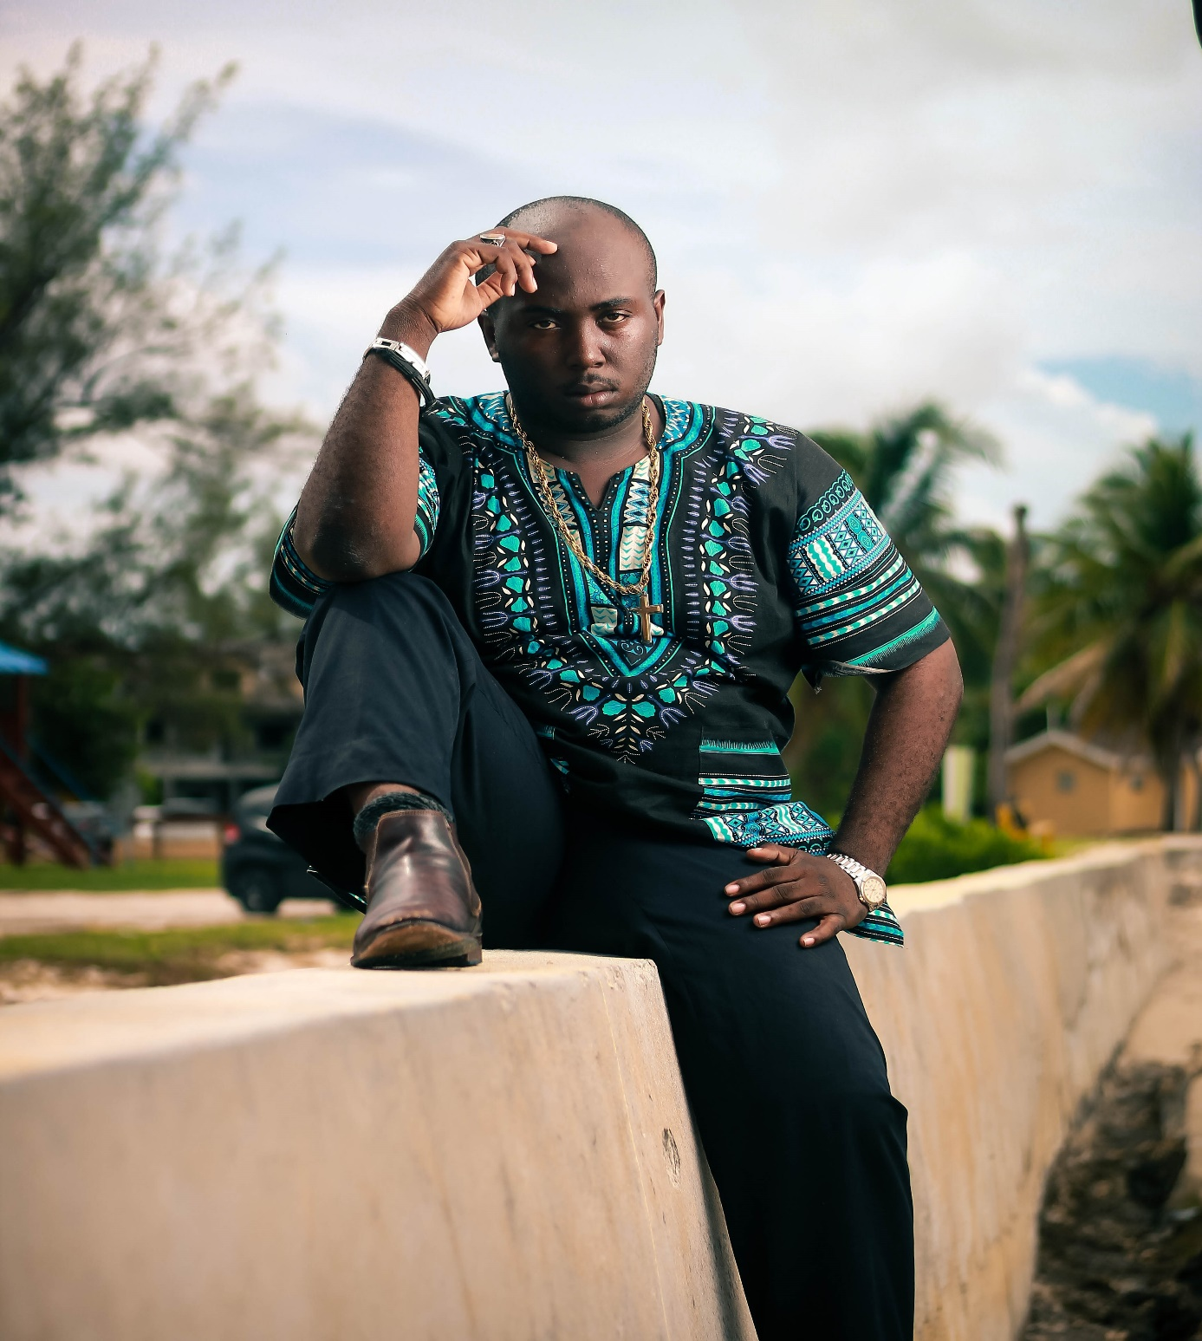
Title: The Manuscript: Volume I
Subtitle: Annotations from the Margins of a Comeback
Written by: Mr. Andre’ Davis
Author’s Note
I don’t even know the right words to start. I want to start by introducing myself, my name is Mr. Andre’ Perez Davis. I am a writer, poet, man of God, upcoming spoken word artist and an aspiring author. This manuscript is a collection of moments, thoughts, reflections that have carried me through seasons of pain, struggle, change, transition and now growth that I have written to lift me up and remind me of who God is.
These are my words. Raw, unfiltered, emotional, painful, triumphant, tortured, humble, broken, freeing, redemptive and most of all MINE. They were written as I lived them. Broken and all. I found solace in placing my pain on the page, whatever that looks like. Each chapter of this e-book has something of importance for any man of God or woman of
God that just needs to be reminded of who they are.
Let me be transparent here. I lost my mother at 17. I then lost my father at 20. I struggled with addiction to pornography, fast food, soda and coffee for 5 years. The Lord freed me from all of that. This book is to show anyone that has gone through any kind of trauma, that redemption is possible.
None of those things I mentioned defines me. For I am an overcomer. I am a conqueror through Jesus Christ our Lord. For Joel 2:25 says, ‘’I will restore to you the years that the swarming locust has eaten- the great locust and the young locust, the other locusts and the locust swarm- my great army that I sent among you’’. The last part means that all things work together for your good. He is
forever going to use your pain to become your purpose.

My prayer for you, my brothers and sisters is that as you all embark on this journey of redemption with me, is that you see that even in the margins, a comeback is possible. So now, without further ado, I am so proud to present to you all: Annotations from the Margins of a Comeback.

Andre’ Davis
Writer and Author
Annotations from the Margins of a Comeback

Table of Contents
Chapter One: Andre’ (Intro)
Chapter Two: I’m not the same
Chapter Three: Older
Chapter Four: Hoax (Epilogue)
Chapter Five: Post Mortem
Chapter Six: Personal
Chapter Seven: Cardigan
Chapter Eight: The Manuscript
Addendum: Pages Found After the Comeback
Chapter Nine: Tired
Chapter Ten: Process
Chapter Eleven: Waking Up
Chapter Twelve: 2 Hands 2 Heaven

About the Author (Contact Info)
Acknowledgements

Chapter One: Andre’ (Intro)
By: Andre’ Davis

I stand at the precipice
Of something great
Something special that comes
Over the horizon
In my life thus far
It’s already been a journey
But my gratefulness goes deeper than imagined
I have fought battles that only you lord
Have witnessed
I have survived wars that have shaped
The man I am today
And the man I am being transformed into
I have grown taller
More than I ever know
Yes I lost my parents
Yes I became an addict
But it's your love that defines me
Not my struggles
And not what tried to enter the forefront
This is all a process
I get scared and overwhelmed sometimes
That is normal
For I am human
But Lord I will not shy away
From what you're doing in me
For he who begins a great work
Shall be faithful and just to complete it
So in case you forgot
My name is Andre' Perez Davis
A strong resilient young man
A royal priesthood
And God's beloved son
I have been through hell and back
But that was only to fulfill his prophecy over me
Then I hear him whisper my name ever so tenderly

Andre'

Note: Your identity. Knowing who you are and who you belong to is the true key to freedom.

Chapter Two: I’m not the same
By: Andre’ Davis

Lord I'm not the same
Everything has changed
Everything has melted away
And now it's just me and you
I have nothing to say
It's time I embrace the stillness
Father I can't run anymore

Now that the distractions are dead
I truly see that nothing else matters
But you and me
I've been running
Truly running from my emotions
Because quite frankly they hurt too much
Days I feel sad
Others I feel angry
Others I feel happy
It's been quite the five years
But Lord I wouldn't trade it all for anything
Because struggles make way for purpose
And like I always say
Exhaustion makes way for Redemption.

Sitting on my balcony
After a long day's work
Stargazing with you
I was eager to get inside
To wind down and fall asleep
But Lord
I guess you wanted me to see
How lovely your creation truly is.
Seeing as how I love nights

Here I am barefoot with my socks on
Still in my work clothes
Swatting away the flies
That tried to swarm my grave
Trust me I'm not the same.

I haven't been for a while.
So much has changed
I have changed
Boy am I different now.

I learned today
That I have experienced social media dissociation.
Which is completely blacking out
And allowing online to bleed into my reality
The breeze is blowing
I'm lying on the cold tiles
Overlooking the city
It's so beautiful at night
I guess I didn't need to do
Everything that I did.

I'm here in the midnight hour
Reminiscing and reflecting
On all I've been through
And all that I've done

Lord I'm sorry
That I make your sacrifice
And your love
Seem like a mountain I have to climb
Like something I have to earn
When it’s something you have freely given

I've played with fire for too long
Death to those embers
I never checked my pulse
Because all I felt was shame
After spending five years in the grave
Trust me I'm not the same.

I'm not the same.
I'm not the same.
I haven't been for a while now.
Things have changed.
I have changed.

I'm not the same Andre' I was
And quite frankly
My evolution has been painful
Yet beautiful
But one thing that I celebrate truly
Is that even though I am changing
Lord I know that you never do....

You always stay the same....

Note: Pain definitely changes you. In both good ways and bad ways. But God uses even your lowest moments to raise you up.
Chapter Three: Older

By: Andre’ Davis

Its 6am
I'm alone at the bus stop
Watching the cars go by
Replaying the last four years of my life
With you.

I've gotten older
I turn 23 this year
Being an adult
Has taught me to never take for granted
Everything you hold dear.

Jesus I thank you.
Because you could've left when I hurt you.
But you still stayed.
And something tells me
You always will.

I watched porn again
Before I went to sleep.
But you still woke me up in time.
So I can get my money.
How can you be so good?

I leave it all in your hands.
Because I can't carry this anymore.
I've tried and failed.
I've seen this film before.

Mommy I've gotten older
I wish you could see me now.
But I'm thankful you're resting.
Finally at peace.
But I'll be honest.
I sometimes worry about me.

I've fought tooth and nail.
To feel like I'm alright.
But my heart has been heavy.
With every mistake that I've made.
And I'm tired.
So tired.

Daddy I've gotten older
I wish you could see me now.
The scared little kid you knew
Is truly dead and gone.
He had so much that he held onto.
I have so much I'm holding onto
Including him.

The old me is now being buried.
And it's like I'm crying over the casket.
Instead of allowing him to rest in peace.
It's time to let go.
Help me to let go.

Abba
My beautiful father in heaven.
I give myself to you.
I'm not who I was.
But I'm not who I want to be.
And all I can be honest.
Honest with the one who created me.
Even though you already knew.
Who I would turn out to be
Who I will turn out to be.

Abba
Only you know what the end is.
Lord only you know where the end is.
Abba only you know what the end is.

Note: He knows your future. You didn’t go through all of that for no reason.

Chapter Four: Hoax (Epilogue)

By: Andre’ Davis
I was once
The only hoax
I believed in
My faithless love
It came in seasons
I take my mask off
I'm finally breathing
Finally breathing
Lord I switch the perspective
The risk became redemptive
Being lost became who I am
I'm ready to move on
This world is only a hoax
It always has been
A dwindling high that will end
Lord I had a rough day
But I gained new sight
After everything that took place last night
I fell asleep after being touched by you
And woke up at almost 2am
Then again at 6:30am
And started my day
I created God in my own image
Just to feel less alone at night
I was always the hoax
I thought I had it all together
I became the only hoax
I believed in
I used you
Trust me
I'm not dwelling and focusing on me
I'm just being aware
I gratified my flesh
And became a modern day Judas
They say believe in yourself
But that's a lie
Because I will always break my own heart
Lord I broke me first
I kept telling myself I was fine
Because I always put others before myself
I believed my own lies
And idolized the truth
I stood begrudgingly in the mirror
And screamed give me a reason
Lord my love was the only hoax I believed in
I put my heart on a pedestal
And forgot I was human
I thought I knew more than you
I didn't trust you with everything
My love for you was always a hoax
I told you I loved you
But cursed in front of you
I told you I loved you
But gossiped in front of you
I told you I loved you
But doubted and questioned
Your every move
I let myself be deceived
Until I became the deceiver
I let myself be played
Until I became the player
I let myself be cheated
Until I became the cheater
I was always the cheater
All I've been is faithless
My love for you is the only hoax
I believe in.
Lord my faithless love's the only hoax
I believed in
I valued my love
I thought my love was better
I thought my love was stronger
I put my love over yours
And yes I love you
But I hated myself
I thought I was doing the right thing
I thought I had the right idea
But I just died over and over again
You try to comfort me
All I could do is cry
Lord my love for you was always a hoax
Never real
Nothing more
Nothing less
Because I didn't give you everything
But I gave you my heart
And maybe that's enough
All I've been is faithless
But you make me blameless...
Lord you make me blameless....
Note: It’s not about our love for him. It’s about his love for us. Rest in that.
Chapter Five: Post Mortem
By: Andre’ Davis

Post Mortem

After Death I stood
Looking down at my body
I fell asleep on your lap
Never to wake up again
Until the appointed time
I hereby conduct this post Mortem
A deeming of thinking
That I could've done it all alone
That I could've done this on my own
I hereby conduct this post Mortem
For wasting time on things
That became foreign
I fell from the sky
I thought I was depressed
Bags under my eyes
But it turns out I just died
A thousand times over
Can it all just be over?
My eyes grew dark
Separate stages we stood
You were no good
The wages of sin is death
And I guess I paid the price
I hereby conduct this post mortem
My heart is broken
But I can't let you win
I can't let you win
I hereby conduct this post mortem
You destroyed me
But I always bounce back
Always
I slept in the dark
You held me close
I breathed you in
Nothing was ever same
Ever the same again
I stood on the precipice
Between death and rebirth
I couldn't breathe
As I was drenched
As I sunk
Into the ocean of your love
They conducted another post mortem
Because I died yet another time
You told me to die daily
So I could
So I would be with you forever
I close my eyes
I die for the last time
I give up the ghost
For everything I've done
I give up the ghost
For the lies he told
The whispers of hate
That ran my life for six years
Nothing was better
But you make it better
You make me better
Lord you're all I need
You're all I want
You are all I long for
So you stand in the throne room
A peaceful precipice
You look down at me
As you conduct my post mortem
As you conduct our post mortem
You pronounce me free
You rip up the remnants of the autopsy
That kept me on death's door
I became like Jairus Daughter
I was dead no more
Raised like a Phoenix from the ashes
But all I am is your son
I became like Lazarus
You stood outside my tomb
With tears in your eyes
I came back from the dead
And fell into your arms
And cried the whole night
Then Dawn came...
And now I'm free
I'm finally free

Note: He loves you through your worst moments. When you feel like all is lost, he will raise you from the dead like Lazarus and the daughter of Jairus.

Chapter Six: Personal

By: Andre’ Davis

This comeback is personal
It’s a rebirth of the real me
It’s an apology to myself
For not living up to my true potential
For settling for less than what I’m worth
For less than I deserve
I’ve been away for far too long
I haven’t been active as I would like to
Because I’ve been exhausted
I haven’t taken time for me
No one sees the struggle of addiction
I’ve tried to break it
I’ve tried to break free
But it’s a battle only you can win
This comeback is personal
Not only is it an apology to those around me
For falling apart when they needed me
For not being there when they needed me
For leaving them abandoned
Leaving them safe and stranded
For being disrespectful to their time
But maybe it was for the best
Lord you always have a plan right?
Lord I feel your hands
Shaping me oh God
Maybe I’m not needed anymore
They’re doing just fine without me
But my job has kept me away
And I just haven’t felt like doing anything
Anything at all
Jesus this comeback is personal
Because it’s an apology to you
An apology for doubting you
An apology for cheating on you
With other lovers
When I could’ve been with you the whole time
I’m sick of the lies
I’ve told so many lies Lord
So many lies
That I don’t even believe myself anymore
Jesus this comeback is personal
Because of the renewal of my strength
Becoming stronger within the things of God
You’ve spoken so many prophecies
I can’t escape you if I tried
Lord your hand is already over my life
And there’s nothing I can do about it
So Jesus this comeback is personal
Because I’m coming back home to you.

Note: Exhaustion always makes way for Redemption. Remember that.

Chapter Seven: Cardigan

By: Andre’ Davis

I try to focus
But nothing makes sense

I faulted you
For not loving me the way I wanted
The way I imagined

I pass out on the floor
I wake up in the ocean of my mind
My body gets cold
Ice cold
My mind went dark for 5 years
Losing time, losing money

But you gave me life again
I romanticized the feeling of nothingness
Wanting more
Wanting less
Nothing more
Nothing less
You were always the hero
I gave myself to pain
Thinking I would feel better
I gave to myself to "love"
Every time I was under the weather
I cry myself to sleep
Lord I dream of you
I put your love on like a cardigan
Something to keep me warm
When all I ache for is your arms
I ache for you to hold me
But I simply have to trust in your love for me
My tears come out like floods
They taste of blood
I had blood on my hands
For as long as I can remember
I cry for you like a newborn
Then next thing I knew
I was in your arms again
For the first time in forever
I felt safe again
Your love is like a soft cardigan
There's nothing like you Lord
There's no one like you Lord
You know how this all will end
You never pressure me
You don't rush me
I just want to be with you
You don't say I wish you were different
You just whisper I love you over and over
Until I get it
Until it finally sinks in
I've always felt a little lonely
Wishing you would come to life
Even though you are life
Your arms were like a cardigan
I would try to buy when I was sad
Never knowing that your arms
Don't have a price
They never did
We play hide and seek
Like playground lovers do
You've known me forever Lord
I found you at my lowest
When I knew nothing but pain
And you showed me the way
My mom died and I lost all hope

After that night
I didn't try to leave
But nothing could stop me
From plunging into that rabbit hole
To where it would end up being inevitable
Then my dad died
I was at the height of addiction
And I fell apart as it got dark
It came to pass
Lord you showed me how to live again
How to love again.
You knew I would always come back to you.
Like the prodigal son
I come in from the cold
Into the warmth of your arms
I'm shivering and shaking
From the damage I did to myself
But you held me so tight
And I cried in your arms
You let me cry it all out
As you covered me with fresh blankets
Fresh robes and your own cardigan
Straight from the dryer

I learned last night
That I have a faith issue
That's why certain things have taken place
Why I've made certain decisions
Because I've been scared
I'm scared of what it means to truly trust you
To truly let you lead.

I lost myself this year
My priorities got messed up
I'm ready to leave McDonald's and work for myself
I truly feel my faith is being tested right now
Cause I'm stepping on the last train
Being marked like a bloodstain
Going from fear to faith
Growing stronger in places unseen
And I know that fear is not my future
You are.
You are my future.
You are my forever.
I belong to you.
I am yours and you are mine.

I've been through many storms
These past few years
And Even When I felt forgotten
Lord you were always here waiting
Arms open.
And I thought you would give up
And simply change the ending
But you didn't
And you never will.

I cry holy.
I cry wonderful
I cry righteous.
All I can say is thank you Jesus
For all you have done.

Words will never express....

But Lord
Help me to focus on you.
Because if I don't I will short circuit.
Holy Spirit help me.
Help me to listen to the word
And read the word.
Pray and listen to calm music

Because Lord now I've come to the end of myself
And I can't do this anymore
I can't live without you Jesus

I continued to cry
Because I didn't know what to say
But you just kissed my scars
You kissed my scars
As I fell apart
You kissed my scars
And loved me back to life
When I felt like I was a shadow
Of my old self
You wrapped your arms around me
Covered me like a cardigan
And kissed me until I couldn't speak.
Daddy you remind me that I'm your child
Your beloved son
And when life gets hard
I'll remember your love
And like Jacob covered Joseph
With the coat of many colors
I will let it cover me like the softest
And warmest cardigan.

Note: God’s love is like a cardigan. Wear it every day.

Chapter Eight: The Manuscript

By: Andre’ Davis

I have truly changed
In the best way possible
I grew up this past year
Even when I felt dead inside
My mind has written manuscripts
Trying to justify
Trying to over explain and analyze everything
Instead of just resting
And simply trusting
That you are with me

I am not the boy I used to be
I look in the mirror and I love what I see
Thank you for creating me
Thank you for making me who I am
My dearest father

Every time I feel the walls closing in
Help me to run to you
Help me to trust in you Jesus
Help me to choose you
Help me to focus on you.

I cry every time I remember
How much I've overcame
My heart is truly healing
Because you are the author
And the finisher of my faith
You are writing the manuscript of my life.

Note: He is the author and the finisher of your faith. He will never stop writing the manuscript of your life. Just trust him.
ADDENDUM: PAGES FOUND AFTER THE COMEBACK

Finding yourself after years of being lost is a long process. Since I wrote this book for the first time, I have found myself again. I made a comeback that was more than phenomenal and nothing short of grace. These next few pages are how I’ve been feeling recently and I am so excited to present to you: Volume 1: Addendum: Pages Found After the Comeback. Basically a continuation of the previous eight chapters to simply set you all up for Volume 2 coming soon. I love you all so much. Enjoy!

CHAPTER NINE: TIRED

BY: Andre’ Davis

I'll be honest
I've just been a bit tired lately
Not in a bad way
But in a "I'm finally slowing down" type of way
I've been yawning a lot
and sleep has been calling my name
Definitely in a healthier way than before.
I'm in a season of rest
A time to catch up
But a time of rest and relief for my mind
I've been running
And running
And it's time I slow down and relax finally
While still being an adult
And fulfilling my responsibilities
My body and my mind
My heart, spirit and my soul
Are recalibrating all at once
And it's truly up to me to yield
And die every single day
I'm learning a lot
And I feel much clearer
More peaceful than ever
So yes I'm tired
But not because I'm hurting
Father I'm getting better.
Coming out of a fog
Is both freeing and strange
But a good strange
Lord I thank you for freeing me
Lord I thank you for bringing me out of Egypt
My body just is catching up
I'm craving sleep more now
I'm learning how to rest in every sense now
Life is so much more peaceful.
So yes I've been tired
But I haven't been low
I've just been calmer
So no need to worry
I'm better than I've ever been.

Note: Sometimes exhaustion isn’t bad. Maybe it’s just your body recalibrating after all of the pain and trauma. Rest is a requirement not a reward.

CHAPTER TEN: PROCESS

BY: Andre’ Davis

Lord this is a process
One I've resented
Time and time again
You've taken me so many places
That haven't felt good
But it was never about me
It never was
It never was
I lost sight of the process
When I began to see this as a race
And not a Refining
Because that's what this is
But you know I still cry
I still feel broken inside
I try to hide it all
But I don't do a good job
I never do
It always comes back up
I don't want anyone worried about me
Because I did this to myself
I'm responsible for all of it
I should've came to you
When it got hard
Not go to fleeting thrills and pleasures
Now everything hurts.
Everything hurts.
From my head to my toes
It just hurts more than anyone can imagine
I thought I had to fix it fast
Try to make my pain a polished past
But you don't rush
You don't rush
So I won't
I won't
Lord I will trust the process
Even though I'm still hurting really bad
I will trust the process
Lord I trust you
I don't want to shy away
I don't want to rush away
Help me to enjoy the process Lord

Note: This is your process. God has a plan for you. Nobody else can step into your shoes.
CHAPTER ELEVEN: WAKING UP

BY: Andre’ Davis

Lord I'm waking up to you
I'm waking up to your sacred truths
You knew me
Before I took my first breath
You knew me before my mother knew
She would ever conceive
As Psalms 139: 18 says
For when I awake I'm still with you
Even when I run, you still follow me
Even when I falter
You cover me in your love
You knew my life
What I would do
Who I would meet
Who I would be
You've always love me
You were there in the secret place
When my form was made
I was your son before I even knew it
So I will relax and I will rest in your love
Because you know me better than I do
For You know my name
You know what I'm going to say before I think it
Let alone before it comes from my mouth
You know the number of hairs on my head
Like your word says the sparrows are taken care of
So how much more does you love me
So I'm waking up and I'm remembering
What you say about me
That I'm known, loved and seen by you.
Lord you see me.
You see what I hide.
You see me.
Help me to abide.
For only you truly see me....

Note: He loves you more than you know. The Bible truly tells you so. Relax in his love.



CHAPTER TWELVE: 2 HANDS 2 HEAVEN

BY: Andre’ Davis

I put on my clothes
In a gentle and tender way
Slower than I ever have before
I took some time to take it all in
You really love me, don't you?
My body has been through a lot
But you made me fall in love with me again
I stand still, I close my eyes
And raise my 2 hands 2 heaven
My home in the sky
I'm not going to worry about what's next
For you know the plans you have for me
Plans that are good and not evil
Plans to give me hope and a future
Plans to prosper me and not to harm me
For you are my father and you love me
I lift my 2 hands 2 heaven not because you are far
But to praise you for how close you are to me
People sing about you
Like you're far away
Like you simply look at us
But don't reach out
But you brought me closer
You brought us closer
You're closer than my breath
The breath in my lungs
For the scripture says I will lift up mine eyes
To the hills from whence cometh my help
My help comes from the Lord
The Lord which made heaven and earth
You see that word heaven
He made that
You see that other word earth
He made that too
For I refuse to be shaken
To be moved by other forces
For they are reduced to nothing
When he's here with me
So when I raise my 2 hands 2 heaven
I'm not reaching for him because he's unreachable
I'm reaching to say "I choose you Lord"
I'm reaching to say "You hold my future"
I'm reaching to say "I love you Lord"
I'm reaching to say "I thank you and I worship you Lord"
For it is Only you I want
For it is Only you I need
So I lift my 2 hands 2 heaven
Not just for me
But for those I love
For Those who don't know you yet
And Those who can't lift their hands to you
I cry, when I think of what I have conquered
So The least I can do is keep this posture
My tears are like waterfalls
When you fill my heart with your love
So I lift my 2 hands 2 heaven in holy adoration
Because I didn't make it through it all
I couldn't make it through it all
Without you holding my hand
So I kneel and bow my head
And Lord I reclaim my space
My rightful birthright as your beloved son
In whom you are well pleased.

Note: Even when you feel alone, he is right there with you. He is truly closer than your very breath.

About the Author
Mr. Andre’ Davis

Mr. Andre’ Davis is a writer, poet, spoken word artist and storyteller who uses his words to process and navigate life, faith, love and honestly and truly his relationship with Christ.
Having been through the death of both parents and a hard fought battle with addiction, he sees his struggles as purpose not pain. He believes in the power of expression and authenticity, because your story is not for you, it’s for someone else who needs to know that God is a healer, deliverer and everything you need him to be.
It’s all about strengthening your testimony for him. For God is the writer of your Redemption story.

You can find Andre’ Davis and more of his reflections and work at theandrecollection.org


Mr. Andre’ Davis
Author and Writer

Acknowledgments

I would like to thank my father in heaven first and foremost for positioning me and telling me to get back up and use my talents. None of this would be possible without you Jesus. I love you. I would also like to thank my parents Donna Louise Williams and Stan Fritzpatrick Davis. I love and miss you both so much. I would also like to thank my Grandparents Archbishop Ros (Bishop) and Pastor Althea Davis (Grammy) for pushing and loving me through every setback. I love you both. I would also like to thank Bishop Trent Davis (Uncle Trent) and Pastor Terez Davis (Auntie Rez). Thank you both for never giving up on me. Thank you both for loving me and seeing me through this comeback. Thank you to my siblings, Aaron, Aami, Anya, Marcus and Nathan. I love you all so much.
Thank you also to all of my extended church families. My Golden Gates family, My World Outreach and St. Peters families. Thank you to all of my friends. There are too many to count. I love you all with every beat of my heart.

Thank you all so much for loving me even when I didn’t feel like Andre’. Let this book be the indication and reminder that I’m back. I’m sorry I took so long.

PS: I’m writing from the future. The comeback is complete. Volume 2 Coming Soon.



